IDEATION PHASE

Define the Problem Statements

Date | 28 September 2026
Team ID | 6ab221341
Project Name | Implement Client Script & UI Policy (Incident)
Maximum Marks | 2 Marks

Customer Problem Statement Template:
Create a problem statement to understand your customer's point of view. The Customer Problem Statement template helps you focus on what matters to create experiences people will love.
A well-articulated customer problem statement allows you and your team to find the ideal solution for the challenges your customers face. Throughout the process, you’ll also be able to empathize with your customers, which helps you better understand how they perceive your product or service.
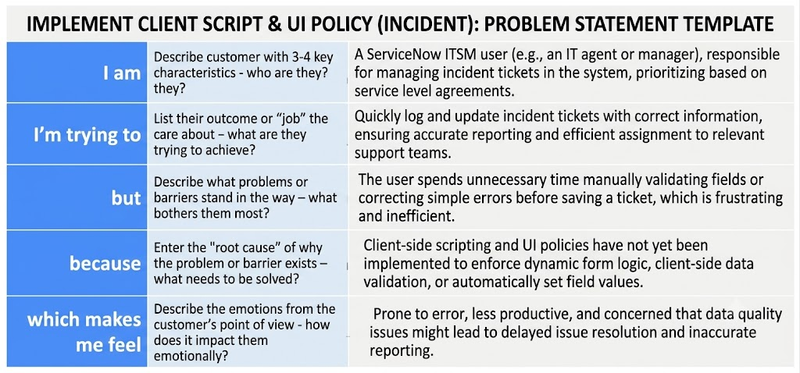

Example:

Problem Statement (PS) | I am (Customer) | I’m trying to | But | Because | Which makes me feel
PS-1 | An IT Support Agent handling ServiceNow tickets | Log and resolve incident tickets quickly and accurately | I spend extra time fixing manual form errors and missing details | The form lacks real-time Client Script validation and automatic field responses | Frustrated, delayed, and prone to data entry errors
PS-2 | An Incident Manager tracking team performance | Ensure high data quality and strict SLA compliance for incidents | Submitted tickets are often missing key details or proper field logic | UI Policies are not configured to dynamically enforce mandatory fields based on ticket state | Stressed, concerned about SLA breaches, and overwhelmed by data cleanup

